Exercise 5:
- SELECT f_name, l_name, title FROM employee_data WHERE title IN ('Senior Programmer', 'Multimedia Programmer');
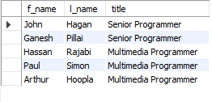
- SELECT f_name, l_name, salary FROM employee_data WHERE salary BETWEEN 70000 AND 90000;
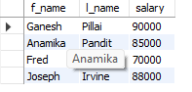
- SELECT f_name, l_name, title FROM employee_data WHERE title NOT IN ('Programmer', 'Senior Programmer', 'Multimedia Programmer');

- 